Cost-Sharing is project cost not borne by the grant sponsor; it is also known as “matching or in-kind contribution” by the University. Cost-sharing involves pairing a “fund number” with a WBS element and can be done as part of completing Account Assignment.

Role: Shopper | Frequency: As needed

BEGINNING STEPS
1. Start Shopping Cart as normal by clicking Set Values | 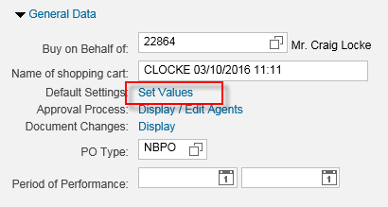
2. Select Account Assignment tab. Set WBS Element (i.e., grant) number as normal. | 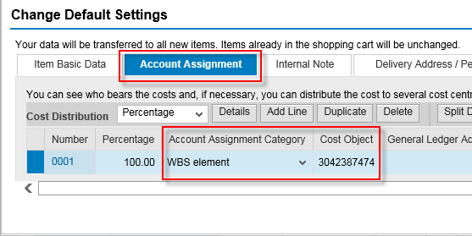
3. With the accounting line item highlighted, click Details button to expand lower section. | 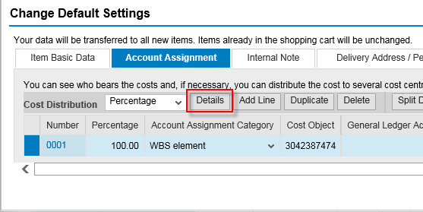
4. The lower section, when expanded, allows extended accounting entries. To provide for cost sharing, overwrite the Fund number to the right with the new cost-share fund number.  Continue completing Set Values with Delivery Address data and complete remainder of Shopping Cart as normal. | 