Process: Some University departments have centralized procurement responsibilities. Specific individuals within administrative areas perform Shopping tasks on behalf of their end-users. Those without the Shopper role can create “Shopping Lists” on the VWR.com website as items are needed. To ease the ordering process, the Shopping Lists can be downloaded from the VWR.com site and provided to another person holding the Shopper role for placement of the order. The myUK e-catalog and VWR.com contains mirrored content (i.e., both sites hold identical products, item numbers, pricing, etc.). The person without the Shopper role conducts Steps 1 through 8; the person holding the Shopper role conducts Steps 9 through 15.
Role: myUK Shopper | Frequency: As needed

Message Definition
1. The non-Shopper can visit VWR.com and log in under their personal or departmental account. | 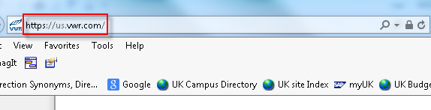  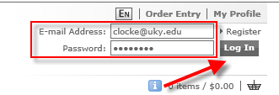
2. Locate needed items along with quantities and place them into a VWR Shopping Basket. | 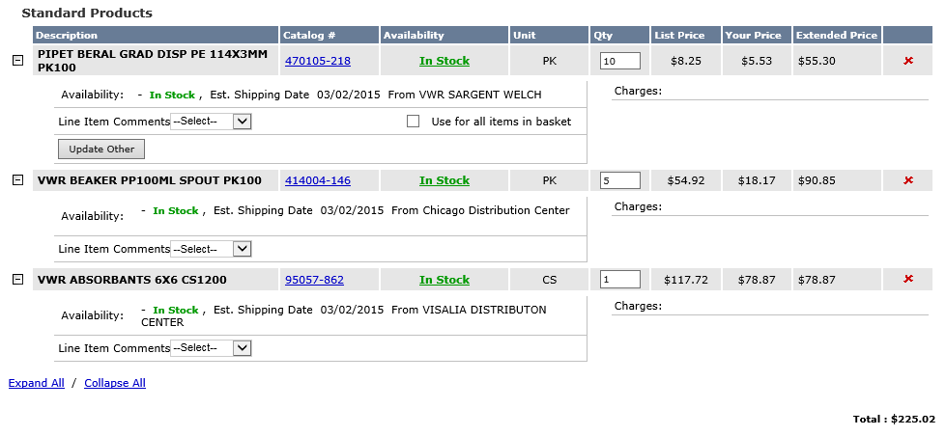
3. Click link at bottom of the screen for Save as a Shopping List. | 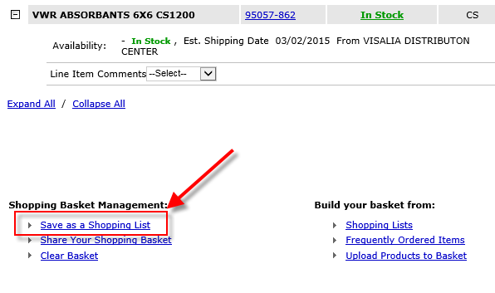
3. Name the Shopping List | 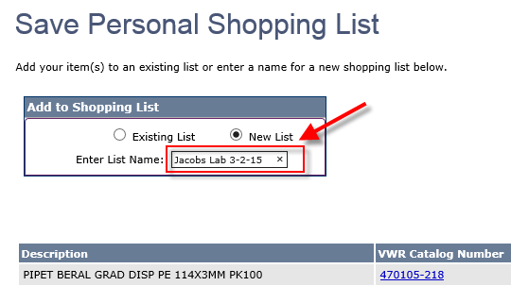
4. Click Submit | 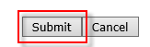
5. Select Personal Shopping Lists under My Account section. | 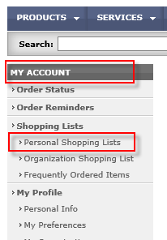
6. Locate the Shopping List and click Download. | 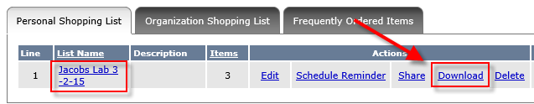
7. Enter the file name and Save the CSV file to your computer. | 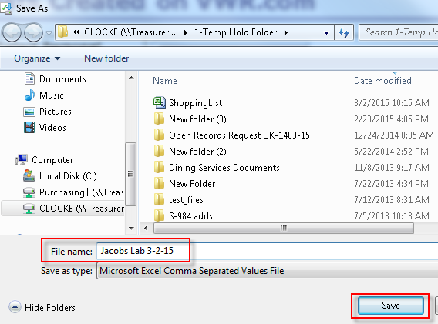
8. Email the file to the person with the Shopper role in your department. The Shopper saves to their desktop. | 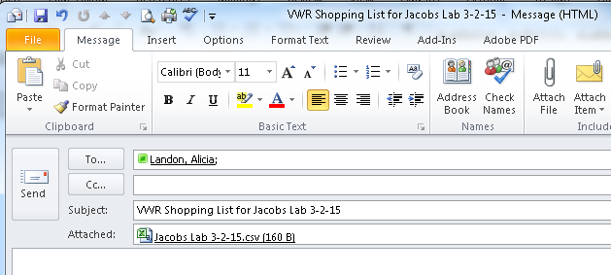
9. The centralized purchasing person with Shopper role begins new Shopping Cart and selects VWR catalog. | 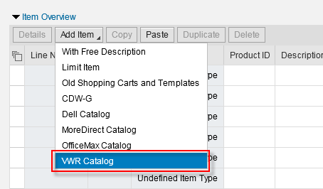
10. Once on the VWR catalog, select Personal Shopping Lists from within My Account. | 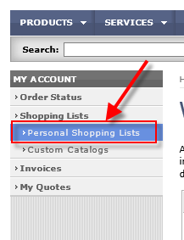
11. Click Browse under Upload a Personal Shopping List. | 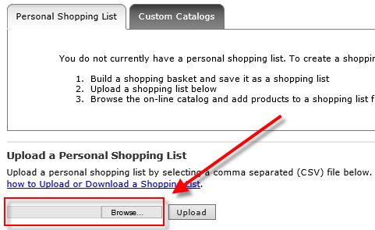
12. Select the Shopping List that was emailed from the non-Shopper and click Open. | 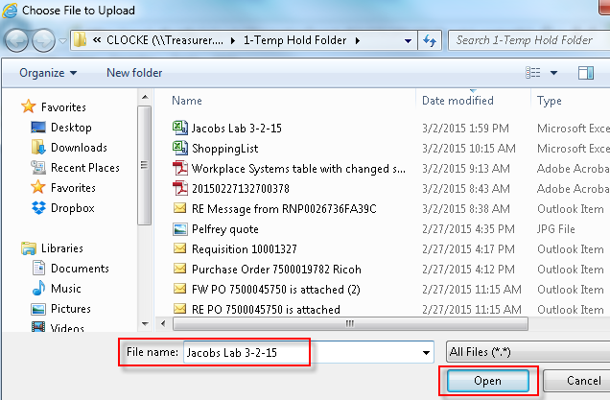
13. Click Upload | 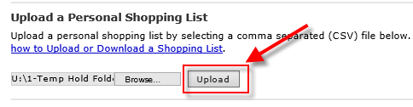
14. The file uploads into the Shopper’s dashboard.  Click Add to Basket to proceed with the purchase. | 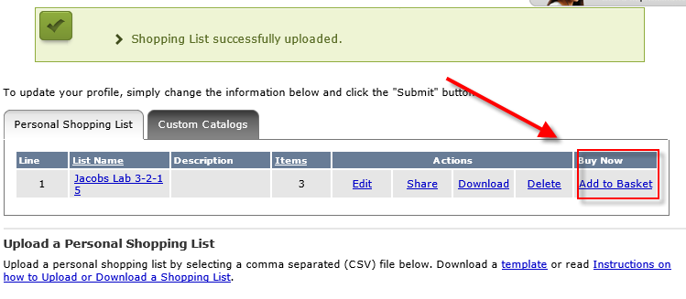
15. The Shopping List items populate into the VWR basket. The Shopper can continue shopping for other items from the e-catalog, or click Checkout to complete order. | 