Process: Shopping Cart Details Report provides line item data relating to Shopping Carts ordered through the Supplier Relationship Management (SRM) e-procurement system. Users can select from multiple search criteria (e.g., date range, created by, cost object, GL account, etc.) to view Shopping Carts meeting the criteria.

The report is available to those holding the Shopper role and can be found within the Shopper’s POWL/Dashboard. It is also available to non-Shoppers who need it for reconciling, reporting, etc. Access for the non-Shopper can be found through the myReports role/ tab within myUK. New users must request and complete course BI_BOBJ_200 to receive the role/tab. In addition, a person’s Area Security Officer (ASO) or other authority may need to authorize which folders and reports are accessible to the user.

Role: SRM Shoppers / Reconcilers | Frequency: As needed

1. Access the myReports tab via myUK | 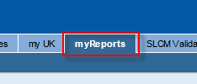
2. Click myReports link on the left portion of the screen | 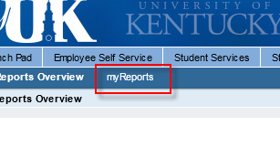
3. From within the Public folders hierarchy on the left, open Materials Management folder.  Click SRM Shopping Cart Report | 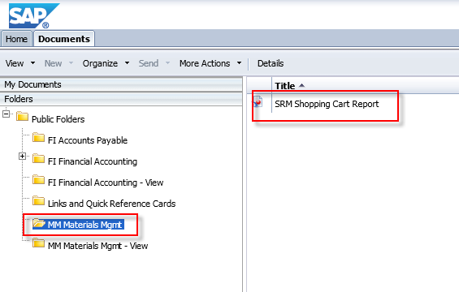
4. A criteria prompt pop-up window displays. The report user can enter single or multiple criteria to view Shopping Carts. Criteria include:  - Cost Center or WBS Element (and other cost objects)  - GL Account  - Shopping Cart Number  - Shopping Cart creator (by UK Active Directory ID) | 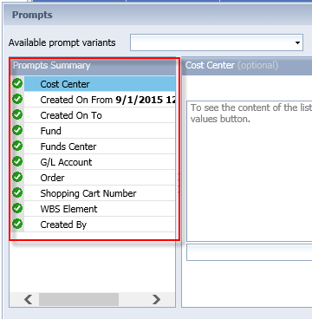
5. Results will display in flat file format. | 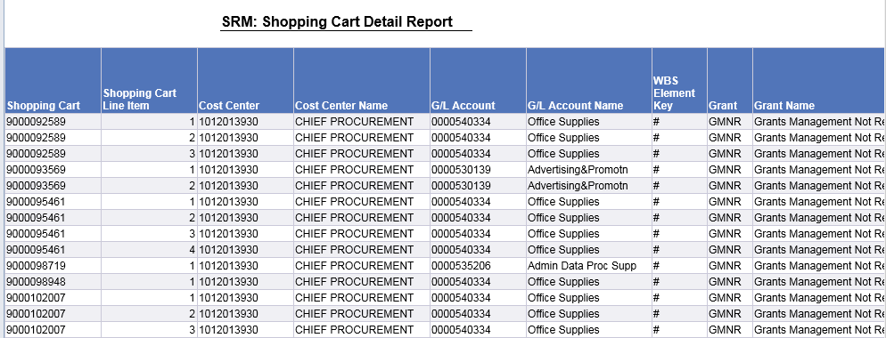
6. User can export results from within myUK to local file if desired. | 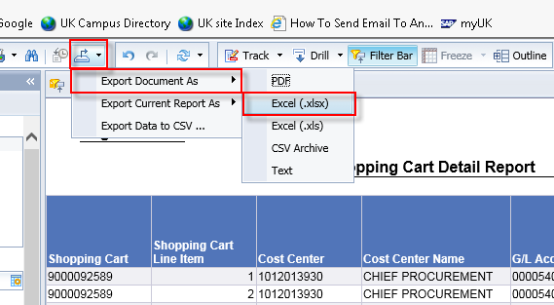
7. User can generate new reports using the Prompt Input menu on the left side if desired. | 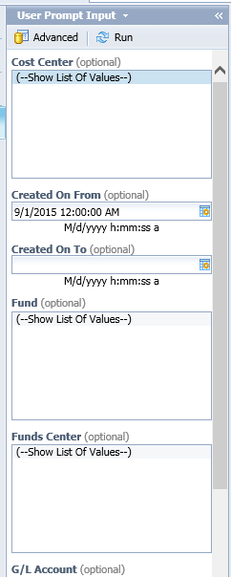
Note: For those holding the SRM Shopper Role, this report is automatically available for use through the Shopper POWL/Dashboard. | 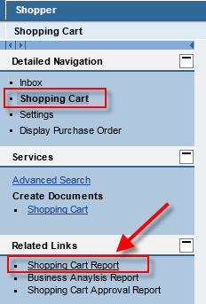
Example 1: User needs to see all Shopping Carts created by users mduncan and clocke for January and February 2015.  1. Click Created On From prompt and enter 1/1/15  2. Click Created on To prompt and enter 3/1/15  3. Click Created By prompt  4. Enter user ID for Shopper and click search icon  TIP: If person is not found, click the Refresh Values icon to retrieve latest information and repeat step 4. | 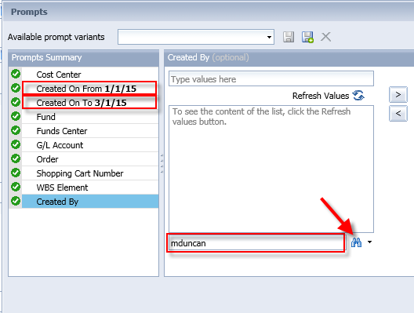
5. After locating the Shopper ID via search, click the right arrow button to move to the search list | 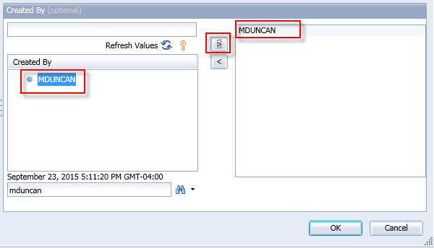
6. Repeat for multiple Shoppers’ names/IDs. Click OK when finished to run report. | 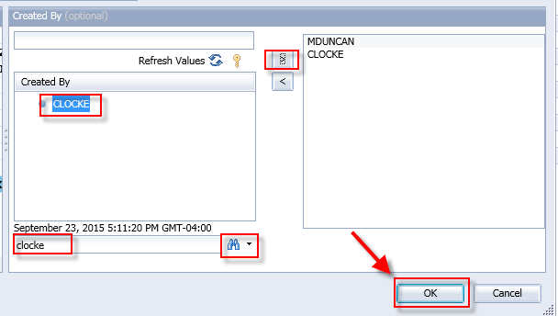
7. Report shows results based on criteria entered. | 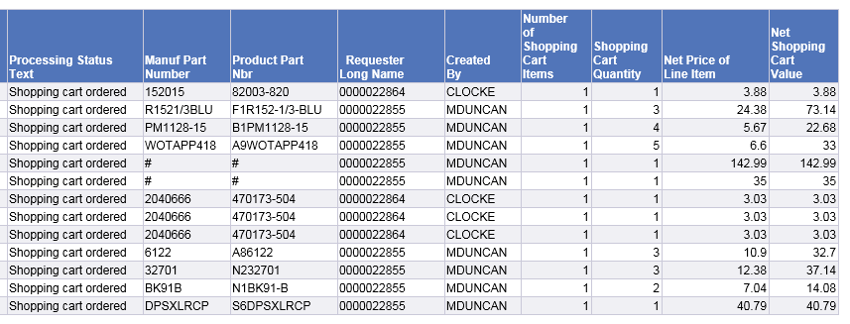
Example 2: Report user wants to see listing of Shopping Carts against a particular cost object for one day.  1. Click Created On From date and provide entry  2. Click Created On To date and provide entry  3. Click Cost Center (or WBS Element, fund, etc. as applicable) | 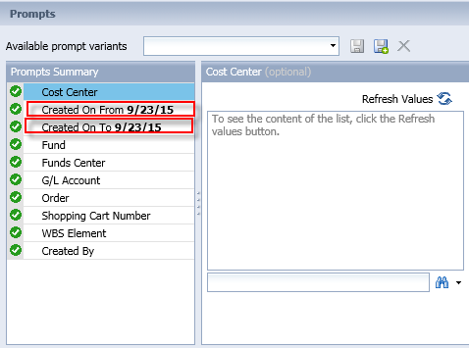
4. Enter the cost center number and click search icon. If valid, the number will appear in the results listing. Highlight the number and click right arrow to move to search list. Multiple cost centers can be added to the list and moved to the right for the search.  TIP: If value is not found, click the Refresh Values icon to retrieve latest information and repeat step 4.  5. Click OK to execute search | 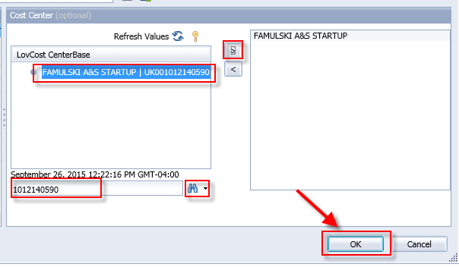
6. Results display and can be exported if desired. | 