Process: The Shopper’s default building information flows into each Shopping Cart from their Personal Settings. Occasionally, it needs changed to a different building on a cart-by-cart basis. For instance, one person with the Shopper role may order and have items shipped to multiple buildings for their end-users. The below steps show how to change the building address on a cart from the default setting to a new building.
Role: myUK Shopper | Frequency: As needed

1. Click Set Values on a new Shopping Cart | 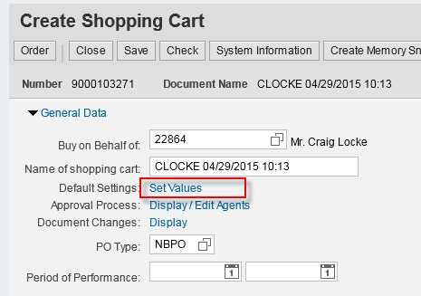
2. Select the Delivery Address tab as normal. The Shopper’s default building information populates. To change to a new building, click the Possible Entries icon on the right side of the Name box. | 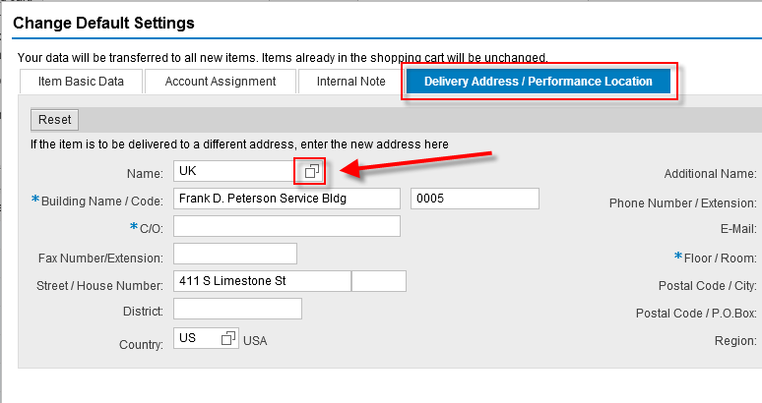
3. The Shopper can enter the building name or simply click Search for a full listing of buildings.  Change the Maximum Number of Results from 500 to 5000, or simply uncheck  Click Search | 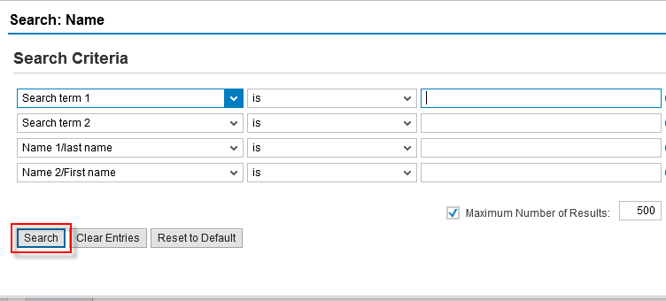
4. The search results appear. Click on the new building. If needed, columns can be sorted by speed sort, building name, etc. | 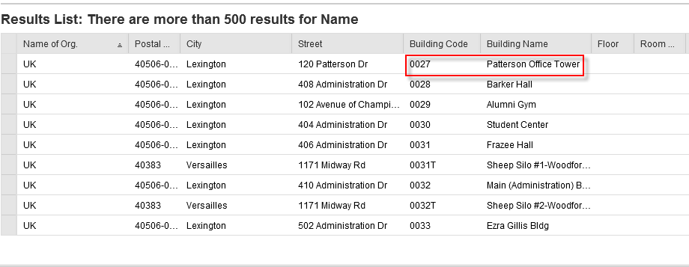
5. The new building address will overwrite the default information on the Shopping Cart. Complete the section as normal with contact person, floor, and room number. | 