Process: Check information related to purchase orders can be found using SAP T-code ME23N (Display Purchase Order). These steps will verify check information for purchase orders created in both SAP and SRM systems.

Role: Various | Frequency: As needed

Message Definition
1. From the SAP Easy Access menu, execute T-code ME23N (Display Purchase Order) | 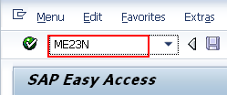
2. Select Purchase Order / Other Purchase Order from the top menu  3. From the Select Document box, enter the PO number, select the PO radio button, and click Other Document | 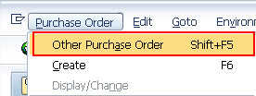  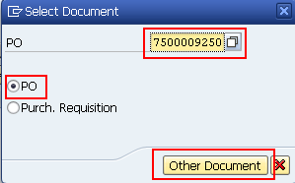
4. The Purchase Order will display on the screen. Go to the bottom Details section and access the Purchase Order History tab | 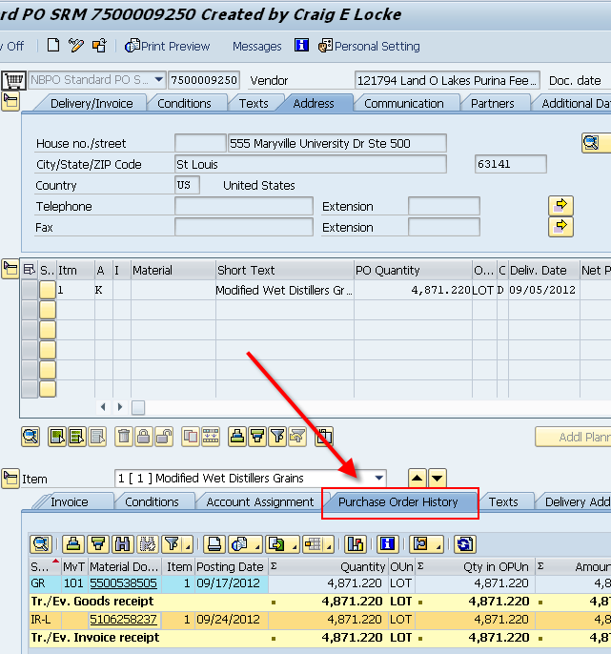
5. Click on the invoice receipt posting number  Note: If the order has multiple line items, it is possible different invoice receipts may be associated with each line item. Use the up/down arrows to move between line items as needed. | 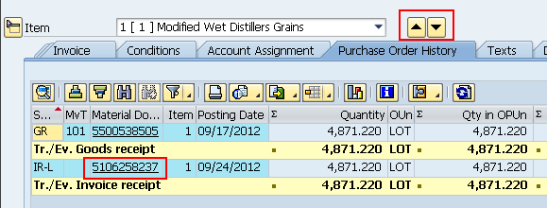
6. Click Follow-On Documents button | 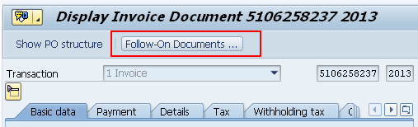
7. Double-click into Accounting document number | 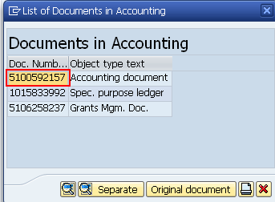
8. Double-click into the amount on the vendor line item | 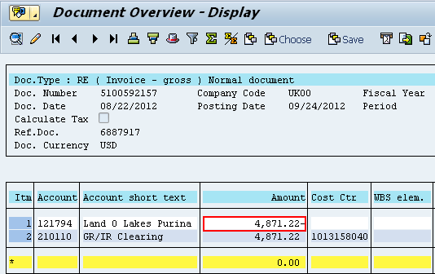
9. The Display Document: Line Item 1 screen will provide additional information regarding the transaction including a Clearing date and document number if a payment has been processed.  If the Clearing Document begins with a “2” (2XXXXXXXXX), then a check has been issued for this PO.  If the Clearing Document number begins with a “18” (18XXXXXXXX), the PO was processed through Payment Plus. | 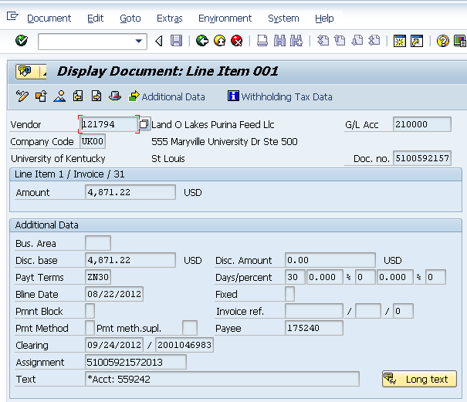
9. From the Display Document screen, click Environment from the menu and select Check Information | 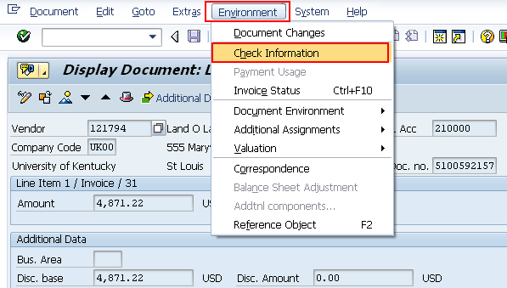
10. Screen will show check number and date of issue | 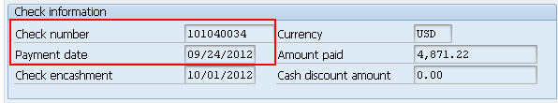
PAYMENT PLUS INFORMATION:  To retrieve the Payment Plus information, copy the Clearing document number from the Display Document: Line Item 001 screen and go to SAP Screen ZFI_EPAY_REGISTER | 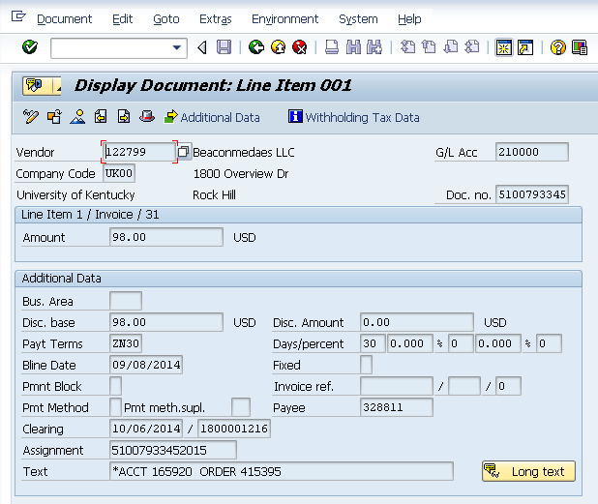
On screen ZFI_EPAY_REGISTER paste the Clearing Document Number into the Payment Document No field.  If the Clearing Document Number was within the last 6 months, Execute the search.  If the Document number is older than 6 months, adjust the Run Date fields and Execute the search. | 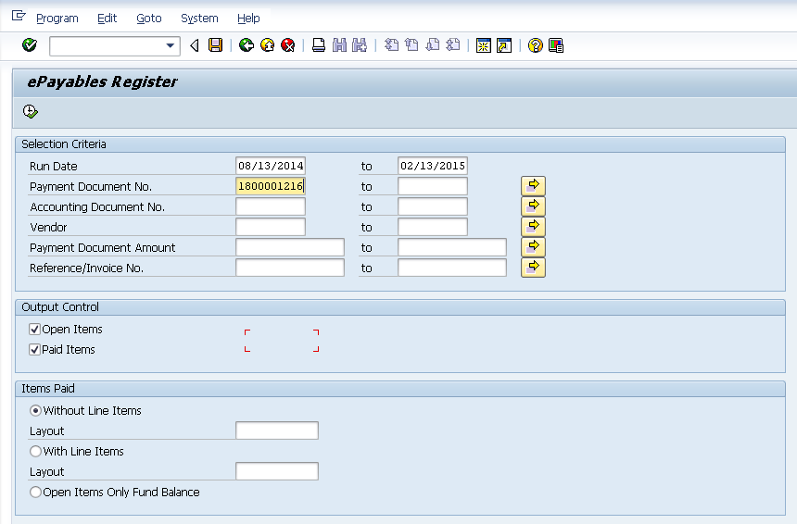  Note: It is required to have a date range in the Run Date Fields to expedite the payment information search. The Run Date Fields will default to the previous 6 months.

