Process: Business Analysis Report provides detailed line item data for purchases made via Purchase Order. It provides for a number of search criteria; results include purchase order documents from all sectors of campus. It is capable of providing a significant number of data columns; users can modify their view layout as desired.
Role: Shoppers / Reconcilers | Frequency: As needed

1a. From within SAP, access T-code zmm_ba_rpt | 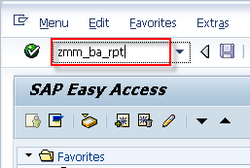
1b. Note: For SRM Shoppers within myUK environment, the report can be accessed within the Shopper POWL.  Click Display Purchase Order from within Detailed Navigation  Arrive at SAP Easy Access and enter the T-code zmm_ba_rpt. Press Enter. | 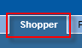  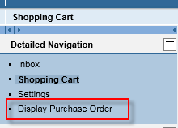  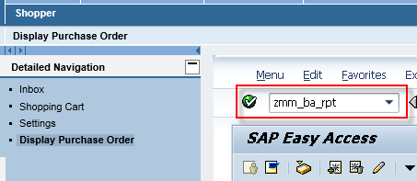
2. Required entry: Document date is the only required field. Enter a suitable date range that will capture the intended data. The report will execute more quickly if data ranges are minimal. | 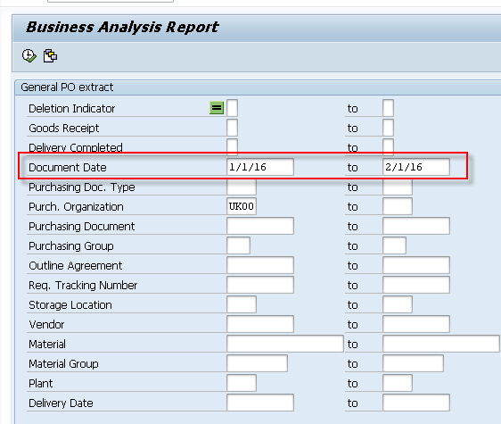
3. Optional entries: All other criteria is optional. Users can search by vendor name, cost center, WBS element (i.e., grant) etc.  User can enter single entries, range of entries, or multiple values. If multiple entries are desired for the same criterion, click the yellow arrow to the right to enter multiple values. | 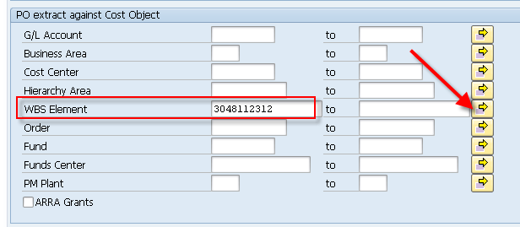
4. Click Execute after completing search criteria | 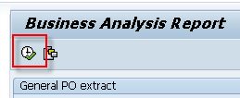
5. Results display in tabular form | 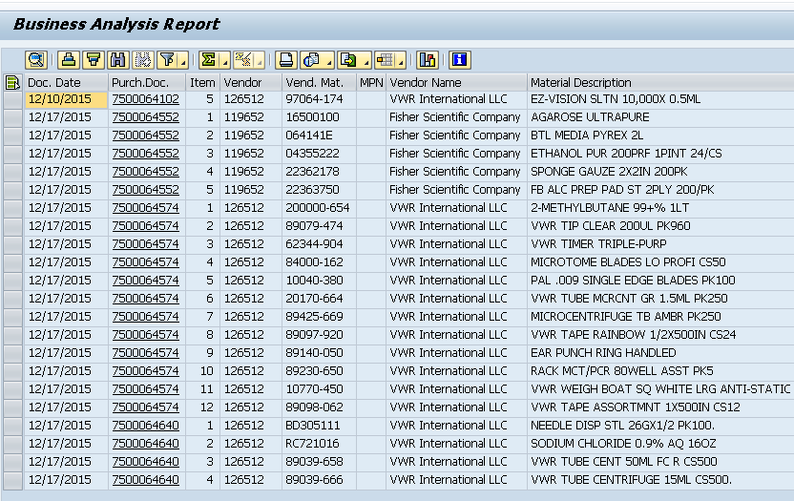
6. If desired, user can select a pre-set layout for improved view.  Select Choose Layout | 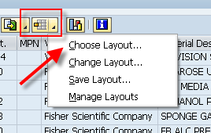
7. The “College of Medicine Layout” provides a common arrangement of data in a format for most viewing/ reconciling needs.  Click College of Medicine Layout | 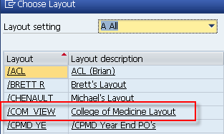
Users can also change an existing layout to a format of their choice and save for future use. The menu contains a Manage Layouts tool also. | 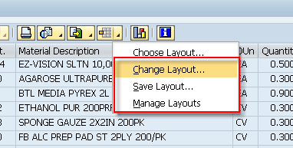
Users can download data to a local Excel file if desired for further examination or manipulation. | 