Overview:

Product Categories are broad descriptors of purchased items. Examples of product categories are computers, furniture, laboratory equipment, etc. Product categories must be assigned to each Shopping Cart line item. For e-catalog orders, the Product Category assigns automatically; Shoppers manually assign the Product Category for line items on Free Text Carts.

GL Accounts are accounting elements that pair with cost centers or WBS Elements. They also have a physical connection to the nature of ordered goods. Examples: Office supplies require a GL Account of 540334.

As a convenience tool for Shoppers, Product Categories within SRM Shopping Carts link to GL Accounts. When a Product Category assigns to a cart, the most common GL Account affiliated with the category autofills for the Shopper. Shoppers can overwrite the suggested GL Account with another if needed.

In addition to GL Account linking, Product Categories perform other functions. They assign and route carts to the appropriate buyer(s) in Purchasing. Commodity reporting is also possible based on product category assignment.

Whenever Product Categories and GL Accounts are manually entered by the Shopper, it is important to remember that the GL Account must be set after the Product Category. If the Product Category is entered after a GL Account, it will overwrite the Shopper’s original entry with a system entry.

Role: Shopper | Frequency: As needed

BEGINNING STEPS
Example 1:
E-Catalog Shopping Cart
For e-catalog orders (e.g., OfficeMax), the Product Category autofills from the catalog. | 1. 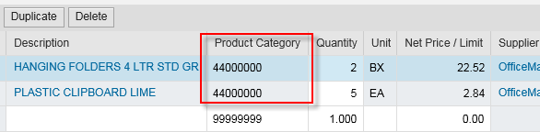
The suggested GL Account also autofills based on the Product Category from the  e-catalog.  Shopper can overwrite if needed at the line item level. | 2. 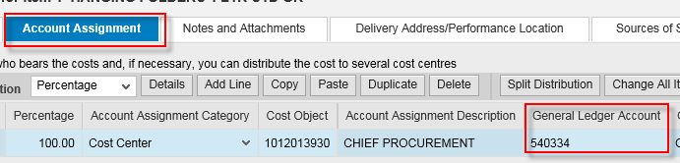
Example 2:
Free Text Order
Shopper manually assigns Product Category as part of line item entry. | 1. 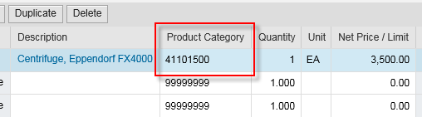
The suggested GL Account autofills based on the Product Category selected by the Shopper. Shopper can overwrite if needed at the line item level. | 2. 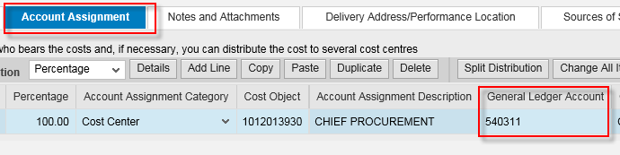
Example 3:
Setting Product Category and GL Account at Set Values Level for Free Text Cart
When beginning a Free Text cart, Shoppers can save keystrokes by setting the Product Category and overwriting the GL account at the Set Values level. This will automatically replicate the entries to all line items placed into the cart. | 1. 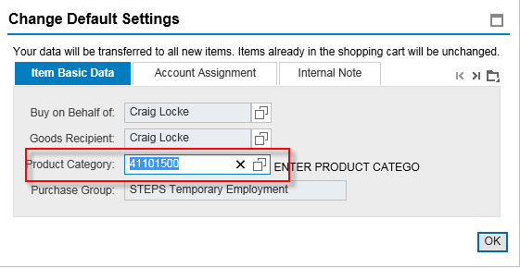
Remember if working at the Set Values level, the Product Category must be set first; set the GL Account second. | 2. 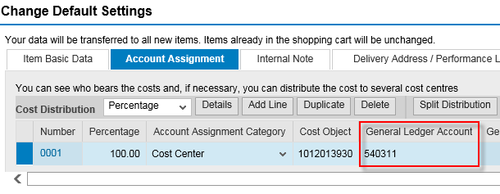
Example 4:
Incorrect Entries for Set Values
Remember: If utilizing Set Values for your entries, refrain from setting the GL Account before the Product Category. The GL Account affiliated with the Product Category will overwrite Shopper’s original entry.  Incorrect Scenario | 1.
Incorrect Scenario | 2.

