Documents can be attached to SRM Goods Confirmations (used within the academic campus) and SAP Goods Receipts (used within hospital and facilities areas). This Quick Reference Card shows how to attach packing slips, for instance, to either type of transaction.
Role: SRM Goods Confirmer / SAP Goods Receiver | Frequency: As needed

SRM Goods Confirmations  (Academic Campus)  1. Scan or convert packing slip or other document to electronic file form and save to your desktop or other location | 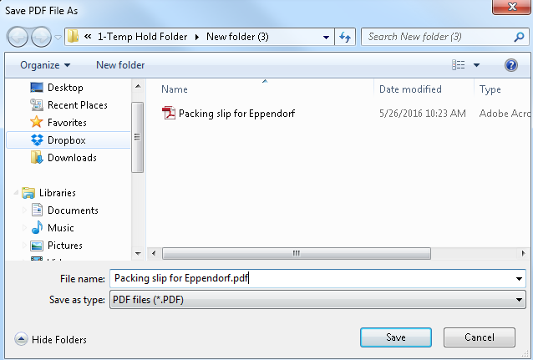
2. Begin the Goods Confirmation as normal. Click Notes and Attachments tab. | 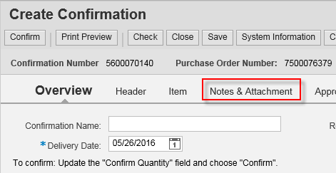
3. Click Add Attachment | 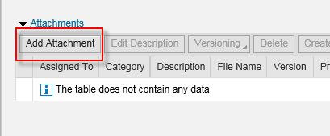
4. Click Browse within the pop-up box | 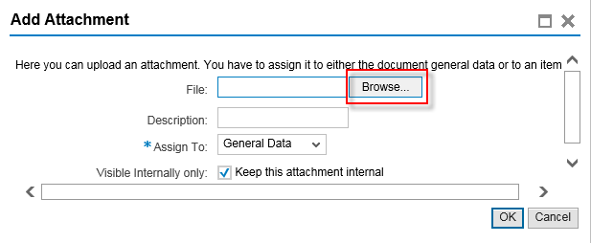
5. Locate and select the file to attach. Click Open. | 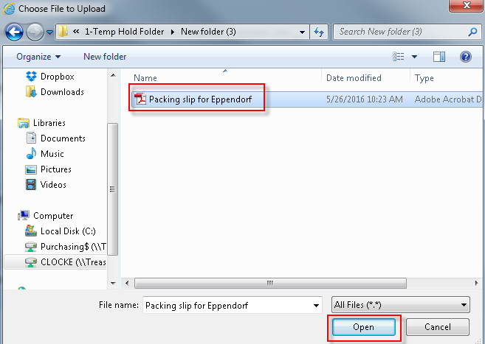
6. Enter a description for the attachment. Click OK. | 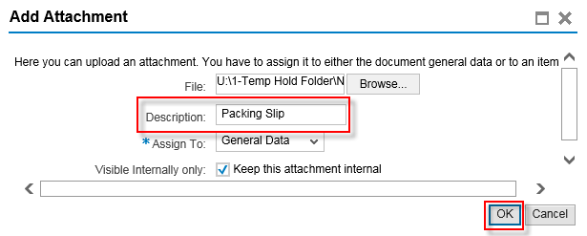
7. Attachment shows successful. Complete remainder of Goods Confirmation and finish as normal. | 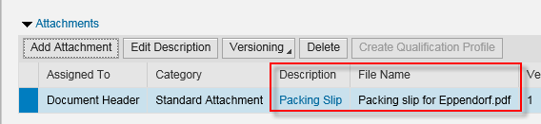
SAP Goods Receipts
(T-Code MIGO)
(Hospitals and Facilities)

1. Scan or convert packing slip or other document to electronic file form and save to your desktop or other location.

2. Begin T-code MIGO as normal to create SAP Goods Receipt. From the Services for Object icon, select Create – Create Document in SAP DB. | 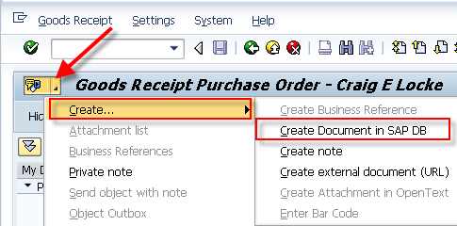
3. Locate and select attachment. Click Open. | 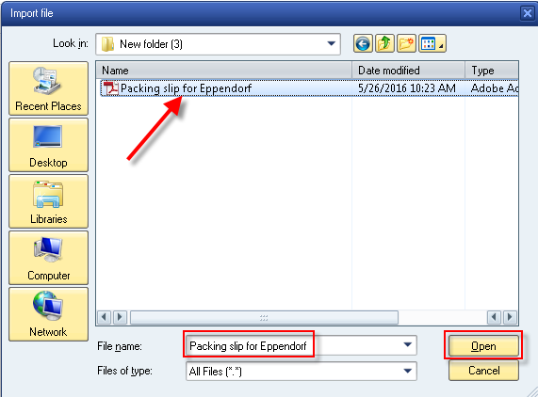
4. Document attaches to SAP Goods Receipt. Complete remainder of Goods Receipt as normal and Save.  Note: The file may not show under the Services for Object menu until the Goods Receipt is completed and Saved. | 